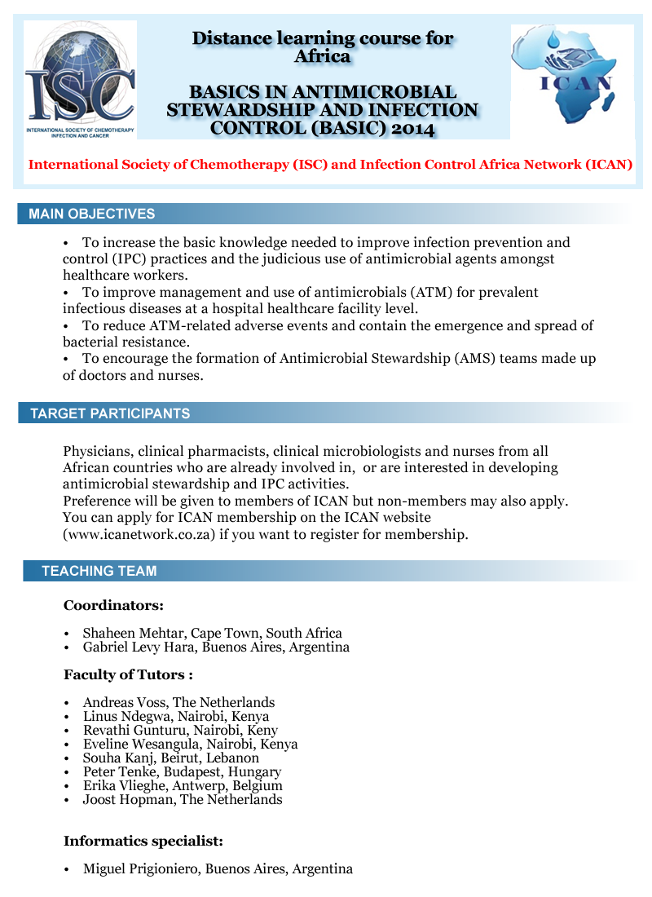

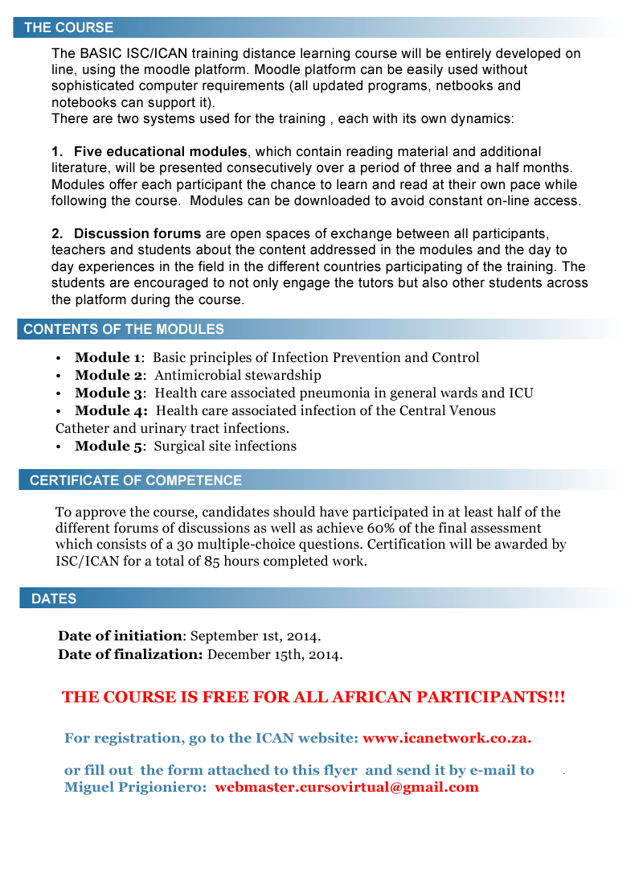

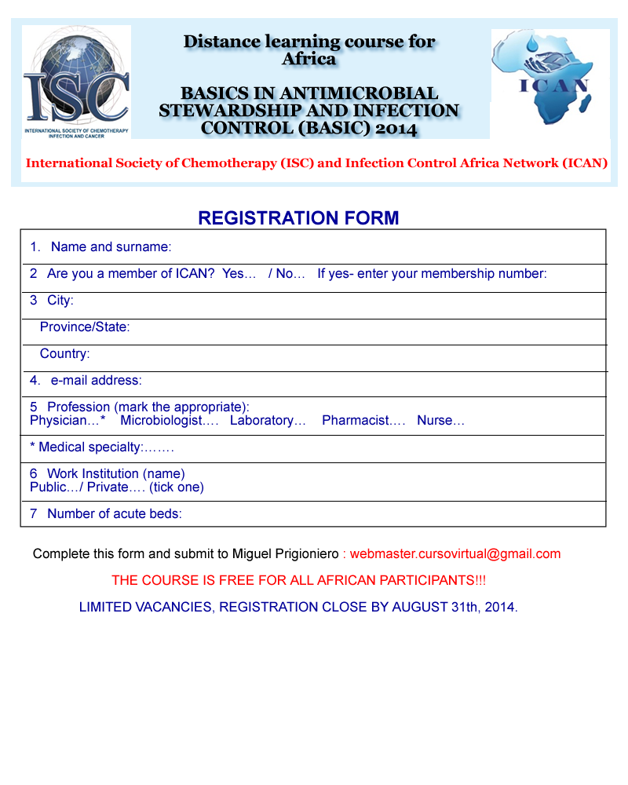

|  |  |
| --- | --- |
| **1.** | **Name and surname:** Click here to enter text. |
| **2** | **Are you a member of ICAN?** Choose an item. **If yes- enter your membership number:** Click here to enter text. |
| **3** | **City:** Click here to enter text. |
|  | **Province/State:** Click here to enter text. |
|  | **Country:** Click here to enter text. |
| **4.** | **e-mail address:** Click here to enter text. |
| **5** | **Profession (mark the appropriate: Physician, Microbiologist, Laboratory, Pharmacist, Nurse, Medical):**Click here to enter text.  **If Medical specialty:** Click here to enter text. |
| **6** | **Work Institution (name):** Click here to enter text. **Public…/ Private…. (tick one):** Choose an item |
| **7** | **Number of acute beds:** Click here to enter text. |

**Complete this form and submit to Miguel Prigioniero:**[**webmaster.cursovirtual@gmail.com**](mailto:webmaster.cursovirtual@gmail.com)

***THE COURSE IS FREE FOR ALL AFRICAN PARTICIPANTS!!!***

**LIMITED VACANCIES, REGISTRATION CLOSE BY AUGUST 31th, 2014**.